**Are Bloggers and blogging important?**

You might have encountered with various people who are content providers for various firms and websites! But, why are these bloggers hired? Is this blogging really important or is it just a senseless trend going on?

Well, various surveys and researches state that around 80% of the websites and companies that make use of blogging are the ones to generate most of their audience and clients with blogging specifically. Also, 82% of the unicorns and various MNCs believe that blogging is an important marketing technique to be opted to build the market.

Providing frequent blogs and content to the websites helps attract numerous folks from the whole of the planet towards the service providers. With the surge in the technique of digital marketing, almost all of the global tech giants and other service providers and businesses have been using blogging as a source of digital marketing to provide information and sources about various services provided and other related niches. And, with the global giants already marking their market places with the trend, small businesses and startups need to opt the same to mark their reigns too.

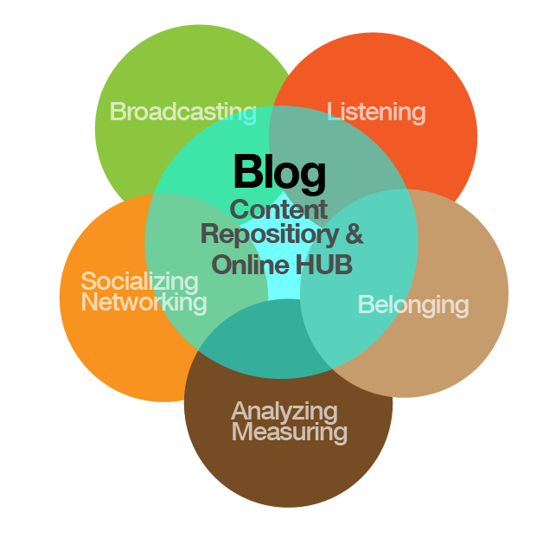

Blogging also helps a large number of people worldwide by generating various useful informative articles and contents to be used for getting any advanced knowledge of any skill or area. This also helps to get a perfect idea about the businesses and the tactics that they use.

**What are the benefits of blogging for various businesses?**

From marketing to generating the audience, there are various benefits that various companies and firms get by including blogging into their websites. The top benefits that are offered by blogging are:

1. The frequent blog providers are the ones that help various search engines like Google and Yahoo with various contents every now and then. And, with this, they become a prominent source for these servers which eventually helps these websites to get Search Engine Optimization and come up to the top search results of the engine. With this, these businesses develop their user-base.
2. With blogging, these businesses can provide continuous engagement to their users and readers. This develops a sense of trust for the readers and thus helps the business with various recommendations that these readers provide.
3. Along with the services, using blogging into the website can help you be a leader in every specific niche. With blogging, one can also conquer the information providing platform and thus target the young generation.
4. With blogging, you can promote your services and show the benefits of your services to your readers. This can help you build a brand for your firm.
5. Blogs are never-ending marketing that does not require any collaboration and extra expenditure. With this, the marketing of the business can continue life-long and help you maintain your success trend across the globe.

**How to be a perfect blogger?**

There are more than 152 million blogs available online on various niches and in about every 0.5 seconds, every new blog goes live online. 55% of marketers prefer blogging to generate the audience with about 77% of internet users reading blogs every day. Since there is a huge requirement, blogging is not going to get a downfall ever soon. With such market trends and stats, with just a slight knowledge of various content generation tips and good grammar, you can be a pro blogger in just a few days and start your earning, like:

1. The most important step to enter this career is to find the perfect niche. You need to get a perfect area that you have interest in and have knowledge about and then build a small portfolio with a few samples in the selected niche. You can choose any niche like traveling, Edtech, fitness, beauty, finance, designing, and decoration, etc.
2. The next step is to start promoting the developed portfolio among your friends and other known people. You can promote your content on social media platforms and other groups too. This will help you build a connection and reach the perfect client sooner or later.
3. Perfectly design the first visible part of your content strategically to give the best impression at the first sight. Make the first headlines catchy and use the best keywords in the content.
4. Apply on various freelancing websites to get freelancing work or if you want to have your website or service, build a blogging website for your content.
5. The blogs provided by you must be engaging and informative and supported by various facts and stats. Also, do not use words or lines spinning to write the same lines again and again in different ways.
6. Provide unique and plagiarism free content for quality services.



Be a blogger and expand the territories!